 **Parcel Summary Tool**

The Parcel Summary Tool allows you to **quickly and consistently identify many sensitive areas and other geographic features** on a property. It was created with **Sections 17.10, 17.17, and 17.18** of the Cache County Land Use Ordinance in mind. While it may be useful for other cities or municipalities, it may not (and most likely *does not*) include all the topics required by their respective ordinances.

**USING THE TOOL**

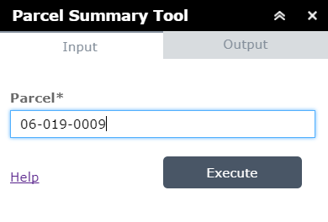Enter a **valid parcel number** in the box labeled “Parcel” and click **Execute**. The tool should switch to the Output tab and show the progress animation while it works. Please be patient; it’s checking over 20 different data sources. **It shouldn’t take more than about half a minute,** unless lots of people are using our maps all at the same time and the server is begging for mercy.

Once it’s finished, it will display a message and provide a link to the Parcel Summary PDF. **Click on this link** to open the file or right click to download it.

**LIMITATIONS**

As noted in our official disclaimer on the PDF, **we don’t (and can’t) guarantee the accuracy of the data presented** on this summary. We obviously do our best, but we are not geotechnical experts or fire district officials. These layers should be interpreted as a warning flag that **more investigation is needed** (which is how the Planning Department uses them).

The tool is overly-cautious: it **checks for anything on the parcel itself and within 100 feet of the parcel**. This makes sure you don’t miss anything that may be important to the property.

The tool will identify any **source water protection zones** 1 or 2 on the property but **does not display them on the map**, nor are they available on the web map. Please come to the Development Services office or contact the Utah Department of Environmental Quality if you have questions.

**ERRORS**

Naturally, this tool will run perfectly, every time, from now to Armageddon. If cosmic rays strike and it somehow fails, it will give an error message in the Output tab. The two most common errors come from entering **an improperly formatted Parcel ID** (should be something like 06-019-0009) or entering a **Parcel ID that does not exist**.

You can contact the GIS Department at 435-755-1640 if you have any questions.